WeLink Video Conference Operation Guide
（For Candidate）

Download PC software and join the meeting
Click “Join(External)” that invigilator had sent to your email, Download the software according to the link guide.
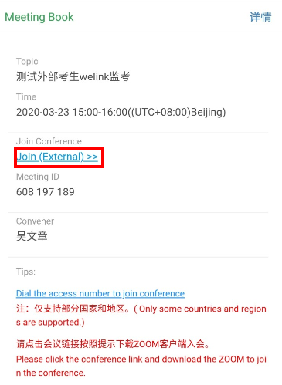

MeetingSettings
1、Open the voice,click “Start video”, and adjust the camera position until you can clearly see your upper body.
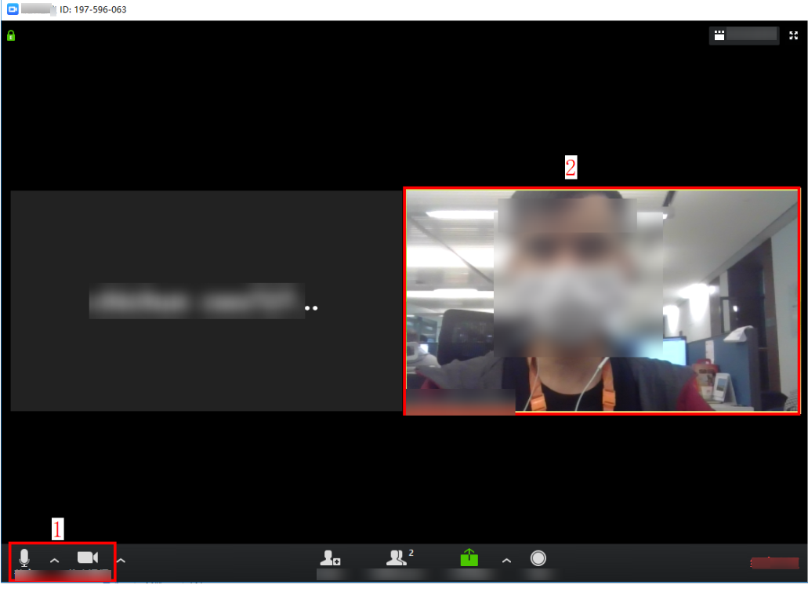
2、Show your ID card to the invigilator to confirm your identity
3、After the identity is confirmed，take the exam according to the <examination guidance>. Do not disable or block the camera during the exam. Switch the screen at most three times (the system will automatically end the exam after three times). Any cheating is not allowed during the exam.
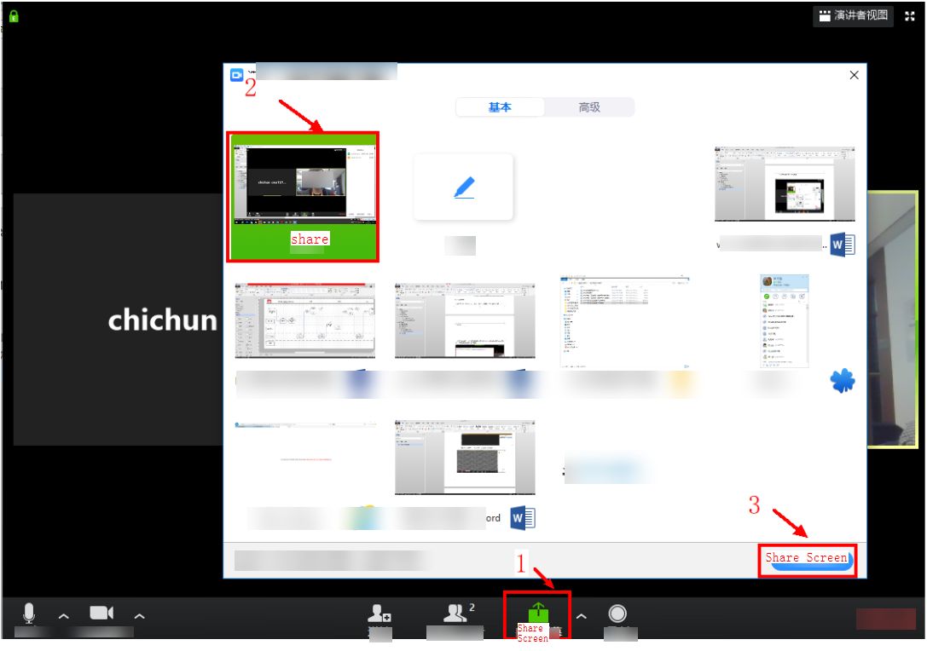

Precautions
- Screen sharing cannot be disabled during the exam.
- If you have any questions, please talk to the invigilator.

